1.
(a) | Express the following periodic signal into exponential Fourier series:  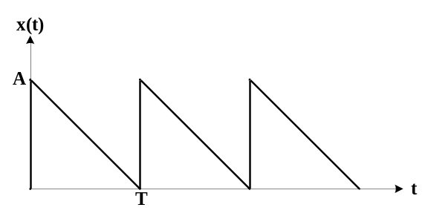 | [7]
(b) | Define linearity and stability of a system. Test time-invariance and causality of following system:  y[n] = ax[n]+b | [8]
2.
(a) | A low pass filter is required to meet following specifications:  Pass band attenuation =1 dB  Stop band attenuation = 15 dB  Pass band edge frequency = 1 KHz  Stop band edge frequency = 2 KHz  Find the lowest order (n) such that the pass band characteristic exhibits equi-ripple behavior. Also compute the same for Butterworth filter and comment on the result. | [8]
(b) | Compare the magnitude response of Butterworth, Chebyshev and Inverse Chebyshev filters. | [7]
3.
(a) | Define z-transform for any causal signal w[n]. Find all possible signals that can have following z-transform:  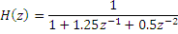 | [8]
(b) | Draw the equivalent lattice-ladder structure of following system:  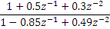  Is the filter stable? | [7]
4.
(a) | Plot the pole-zero diagram of the following system:  h[n]=0.5^{n}{u[n]-u[n-5]} | [7]
(b) | Describe about low pass to band pass transformation of a filter. | [8]
5.
(a) | Explain about zero input limit cycle with necessary examples. | [7]
(b) | Find the Fourier transform of following signal:  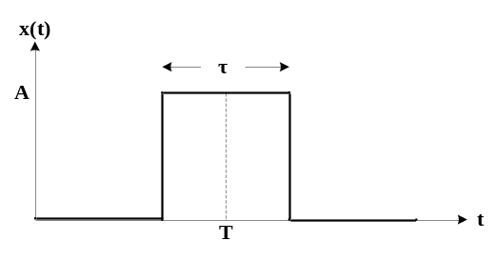 | [8]
6.
(a) | An analog signal is represented by: x(t) = 3cos(100t)+2cos(200t).  - Calculate the minimum sampling frequency that allows exact representation of above signal.  - If above signal is sampled at 1KHz, what will be the folding frequency?  - What will be the data rate in bits/sec, if each sample is represented by 8 bits?  - What is the resolution of above quantizer? | [8]
(b) | Draw the direct form I and II structures of following system:  y[n]-3y[n-1]+2y[n-2]+0.5y[n-3]=2x[n]-0.5x[n-1]+0.7x[n-2] | [7]
7. | Write short notes on (any two) | [5×2]
(a) | FIR and IIR filters
(b) | Location of pole and stability
(c) | Power and energy type signals

